1 Can you find and open the CLI terminal (command line interface terminal) program on the main menu or task bar? *(Hint: It is under the Accessories sub-menu)*.

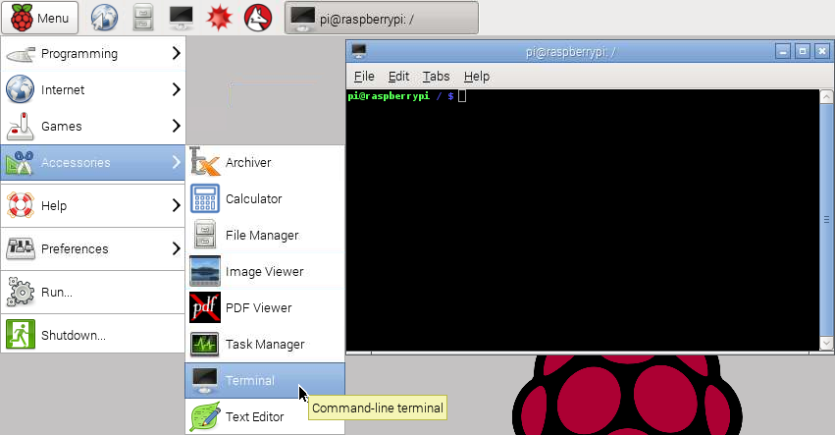

2 The CLI is another way of interacting with the operating system.

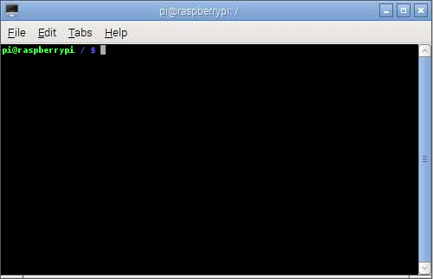

The prompt. When you type it appears here

The terminal

3 Normally the terminal will open the CLI at the root directory by default. On the Raspberry Pi the root directory is called / (just a forwards slash). Can you see where the CLI shows you this piece of information? Linux calls whichever directory you are currently in the working directory

|  |
| --- |
| pi@raspberrypi / $ |

4 The CLI command prompt also shows the user name and the device name. Can you see these?

|  |
| --- |
| pi@raspberrypi / $ |

5 The CLI does not use mouse input so to make the system do something you need to type commands at the command prompt. First you can confirm your location by using the print working directory command. To do so type pwd, which should print out / (for root) on the next line.

|  |
| --- |
| pi@raspberrypi / $ pwd  / |

6 Try navigating to the pi user’s home directory (remember you are logged in as the user named pi). You can use the change directory command by typing cd followed by the directory you wish to change to, in this case /home/pi. Can you see how the prompt changes to show your new location?

For this special directory the CLI command prompt uses a shortcut to show this. Instead of showing /home/pi it shows a ~ symbol (which is called a tilde, pronounced “tild-eh”).

|  |
| --- |
| pi@raspberrypi / $ cd /home/pi  pi@raspberrypi ~ $ |

7 Within the home directory you can see all the other directories and files that it contains using the list command by typing ls.

|  |
| --- |
| pi@raspberrypi ~ $ ls  Desktop Downloads |